Use Case: User encountered error “There was an issue looking up your account”

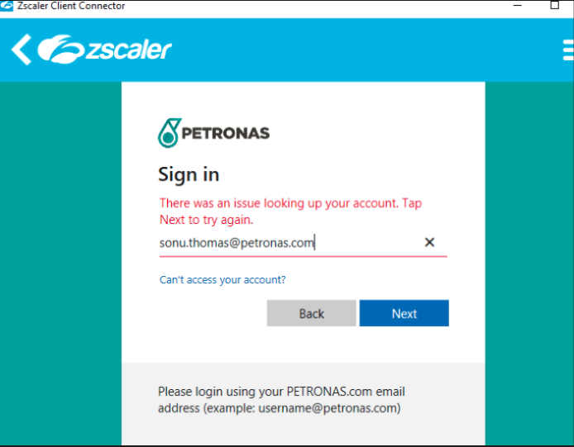
Figure 1: This show user suddenly unable to authenticate through the IDP via ZCC
- Proceed the check the error code 1st, the error code can be obtained by clicking the 3 dots on the right as per below

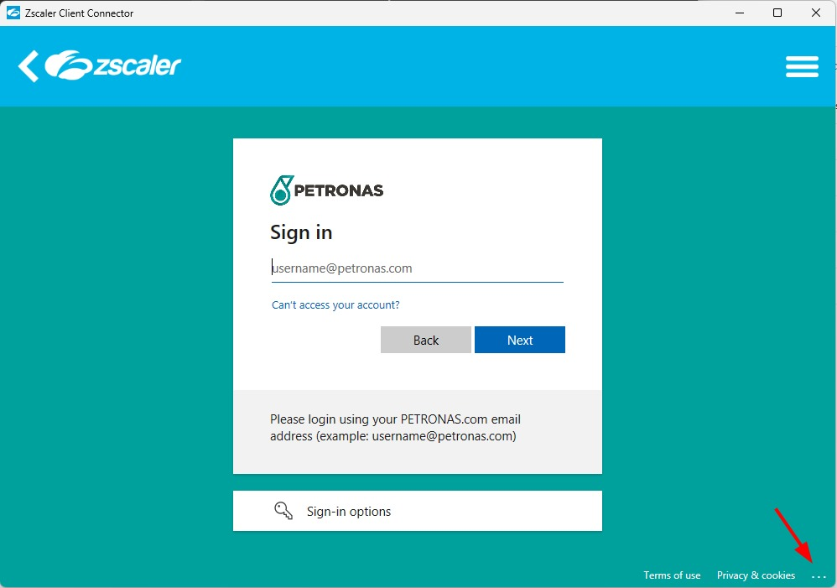

- From there, can see the error code encountered for easier troubleshooting
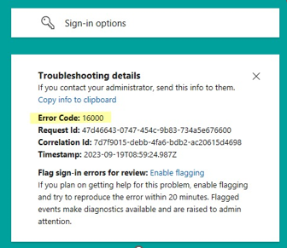

- The figure below explain about the error code and how to solve the issue

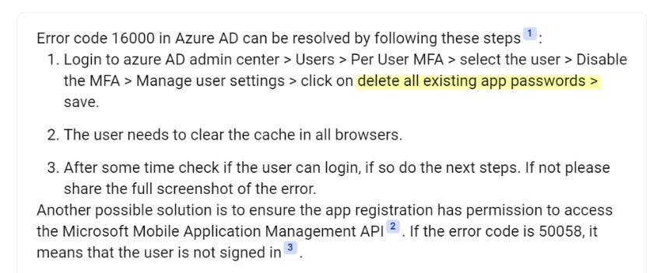

- Proceed to go to the User login Microsoft portal and go to the security info to remove any MFA defined

